How to setup Postman for CTC CMS API Testing

1. On [Postman API Platform](https://web.postman.co/home) Sign-in or Sign-up
2. Once signed in, Navigate to Workspaces -> My Workspace

1. Navigate to Collections -> Import -> Choose Files and import the Collection.json

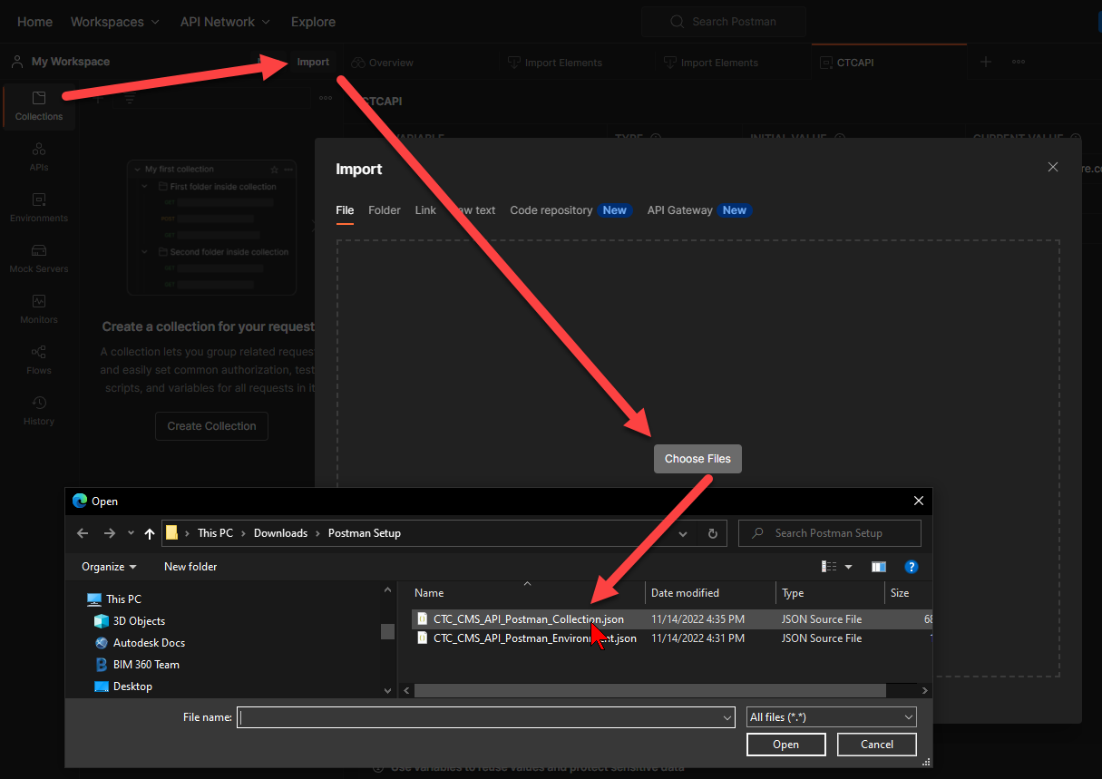

1. Confirm the import of the CMS Reporting API v1 by selecting ‘Import’

1. Navigate to Environments -> Import -> Choose Files

1. Confirm the import of the ‘CTCAPI’ Environment

1. Select the CTCAPI and enter your provided reportsKey into the ‘Current Value’ column and then ‘Save’

1. Be sure to select the active Environment at the top right so the parameters work as desired:

1. Navigate to collection on left, and begin to use the reports

